December, 2013
The 2nd International Rotary Youth and Young Adults Peace Conference
2th - 4th April - home hospitality
4th- 9th - April 2014 –Rotary-Lead-Peace
If you are between the ages of 17-25, and
are passionate about enhancing peace by promoting direct
multi-cultural and multi-faith dialogue among youngsters from around the globe -
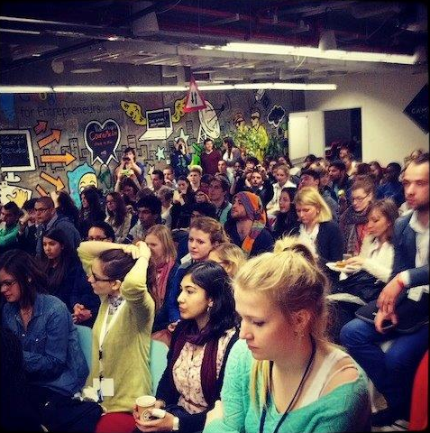
this conference is for you!

About the Conference:
- Dates & Location: The five day conference will take place between the 4th - 9th of April 2014, and will host 150 young people from around the world and Israel at the "Neve Shalom Peace Village", a picturesque village located between Tel Aviv and Jerusalem.
- The conference will include:
- Workshops, think tanks and guest lectures on the topic of multiculturalism
and multi-faith.
- Discussions and debates on shared values in different cultures and faiths.
- 'Peace Through Service' projects to be developed during the conference and subsequently implemented globally in the different communities of the participants.
- Excursions to various ethnic and religious communities in Israel and day trips
around Israel.
- Costs: Participation fees of €175 to be paid by participant or participant's
sponsoring organization. The fees will cover meals, sleeping accommodation and the various lectures, workshops and day trips around Israel.
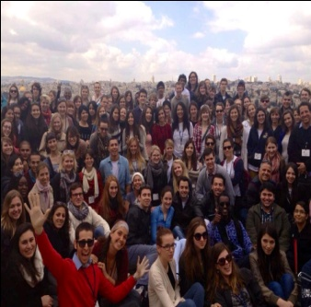
- Please note:
- This sum does not include flight costs to Israel and medical insurance (following Rotary's code of policies), which are to be covered by participants.
- Participants will arrive and leave from Ben-Gurion International Airport.
- The cost of any additional days spent at the youth village either before or after the conference, will be paid for by the participants.
- Pre-conference warm Rotarian home hospitality will be provided for up to 3 days (two nights). Details on the application form below.
- All proceedings and activities will be held in English.

To register to the conference please read the guidelines and fill in the application form here
and submit it by February 7th, 2014.
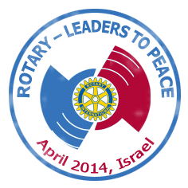
If you require further information please contact us at: rotarypeace2014@gmail.com.

Looking forward to having you with us,

Benny Danino, Shaul D'Angeli
PP & Conference Chair RI 2490 (Israel) District Governor 2013-14
Rotary Israel Rotary Israel

